**Al Imam Mohammad ibn Saud Islamic University**

**College of Computer and Information Sciences**

**Information Systems Department**

|  |  |
| --- | --- |
| **Course Title:** | Web Programming |
| **Course Code:** | IS203 |
| **Course Instructor:** | Sara AL-Rashed |
| **Semester:** | Spring 2020 |
| **Due Date:** | Friday 10-4-2020 |
| **Marks:** | 20 |

|  |  |
| --- | --- |
| **Project Title:** | **Beauty** |

|  |  |  |  |
| --- | --- | --- | --- |
| **Student Name** | **Student ID** | **Section No**. | **Signature** |
| **Bshayer AlGarni** | 438016053 | 372 |  |
| **Razan Alsaawi** | 434030315 |  |
| **Mona Aldebas** | 438021091 |  |



Table of Contents

1. Introduction 6

2. The language used for the system development: 6

3. Project Chapters 7

3.1 Home Page 7

3.2 View item (Gallery) Page 8

3.3 Booking Page 10

3.4 Cancel Page 11

3.5 Contact Us Page 13

3.6 Print Page 14

4. Data Base Tables: 16

5. Conclusions: 17

**Table of Figure**

Figure 1 Home Page 7

Figure 2 Messages 7

Figure 3 Mission and Vision 8

Figure 4 Gallery Page 8

Figure 5 skin and nail item 9

Figure 6 Body scrub and body massage item 9

Figure 7 Booking Page 10

Figure 8 Quantity Alert 10

Figure 9 Time Alert 11

Figure 10 Booking Summery 11

Figure 11 Cancel Page 12

Figure 12 Cancel Alert 12

Figure 13 Cancel Print 13

Figure 14 Contact Us Page 13

Figure 15 Place Picture1 14

Figure 16 Place Picture 2 14

Figure 17 Print Page 15

Figure 18 Print page output 15

Figure 19 Booking DataBase 16

Figure 20 Booking_records database 16

Figure 21 items database 16

**List of Tables**

Table 1 Students Works 5

|  |  |
| --- | --- |
| The work | The Student Name |
| Home Page | **Bshayer**  **Razan**  **Mona**  We usually used to assign tasks to each other but also at most of the time we needed each other to complete the task, we have worked via Zoom online meetings a lot. So, we worked together as a team. And we were thankful about this. |
| View Page |
| Booking Page |
| Cancel Page |
| Contact Us Page |
| About Us |
| Database |

Table Students Works

# Introduction

Every woman in our universe takes care of her beauty, likes to look beautiful and fresh! From this point, we decide that woman deserves a user-friendly and easy to use website that helps her to book some desirable services, such as manicure and pedicure, skin mask, massage or even body scrubbing. We have chosen those services depends on the needs that we might think that the woman like to have when she is tired or even would like to just enjoy it. Also, some of them for example don’t know how to do a specific service so, we found the services that our system offers are really needed. We named our system as “Beauty”. A main point that we would like to notice, what the different between our system and the others. Our system provides a creative online booking system. Which others use the traditional way of booking which might cause some problems.

# The language used for the system development:

We used 5 programming languages to reach this first draft of our system,

* Hypertext Markup Language (HTML):

To start writing a web page, it’s a must to start with HTML as a basic. So, it contains the information the developer wants to send over the web, that information can be represented in different ways. For example: menus, tables, and forms were some of the ways we used.

* Cascading Style Sheets (CSS):

After writing all the information in HTML, it’s time for styling our website! CSS used for styling that information the developer just wrote, such as colors, width, borders, pictures, hover etc. Since we are dealing with users, it’s important to choose attractive and meaningful design that can talks about your domain.

* MySQL:

We used MySQL DBMS to create our database to storage the user inputs and to make a search algorithm we must have a database.

* JavaScript:

We used JavaScript language to improve the functionality in our system.

* Personal Home Page (PHP):

To connect our html pages with our database, we used PHP.

# Project Chapters

## Home Page

It is our welcome page, which short describe about our website and mission and vision. Also, it is including a short audio to make the user comfortable and welcome. There is an interrail linking, hovering and COVID-19 message.

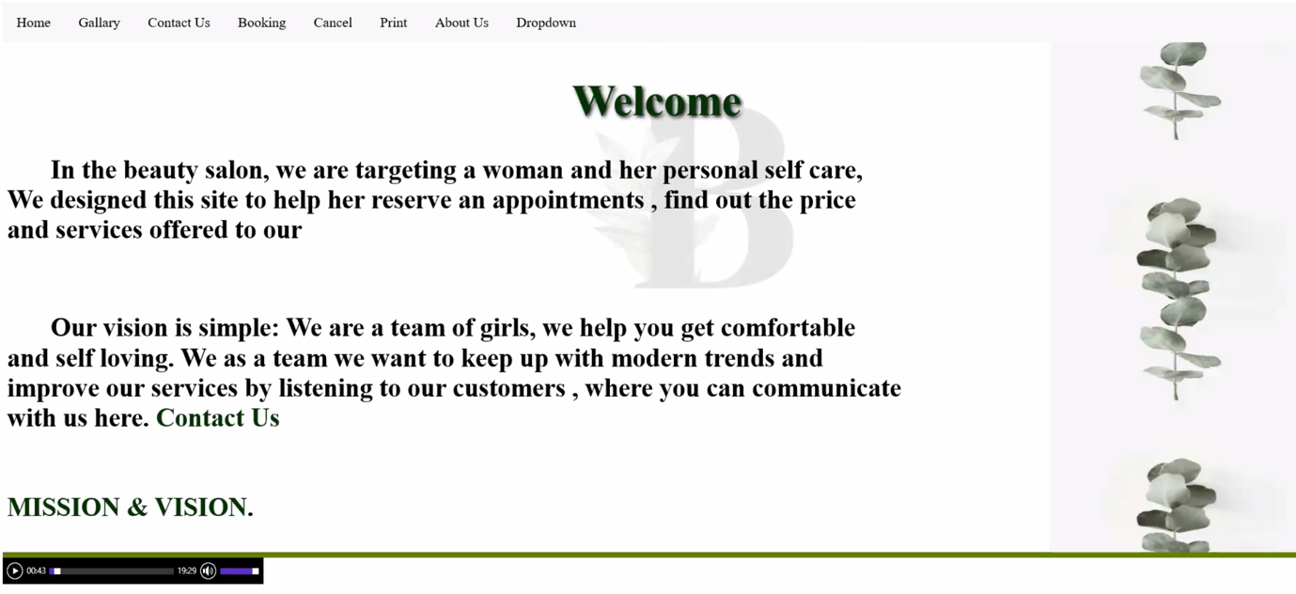

Figure 1 Home Page

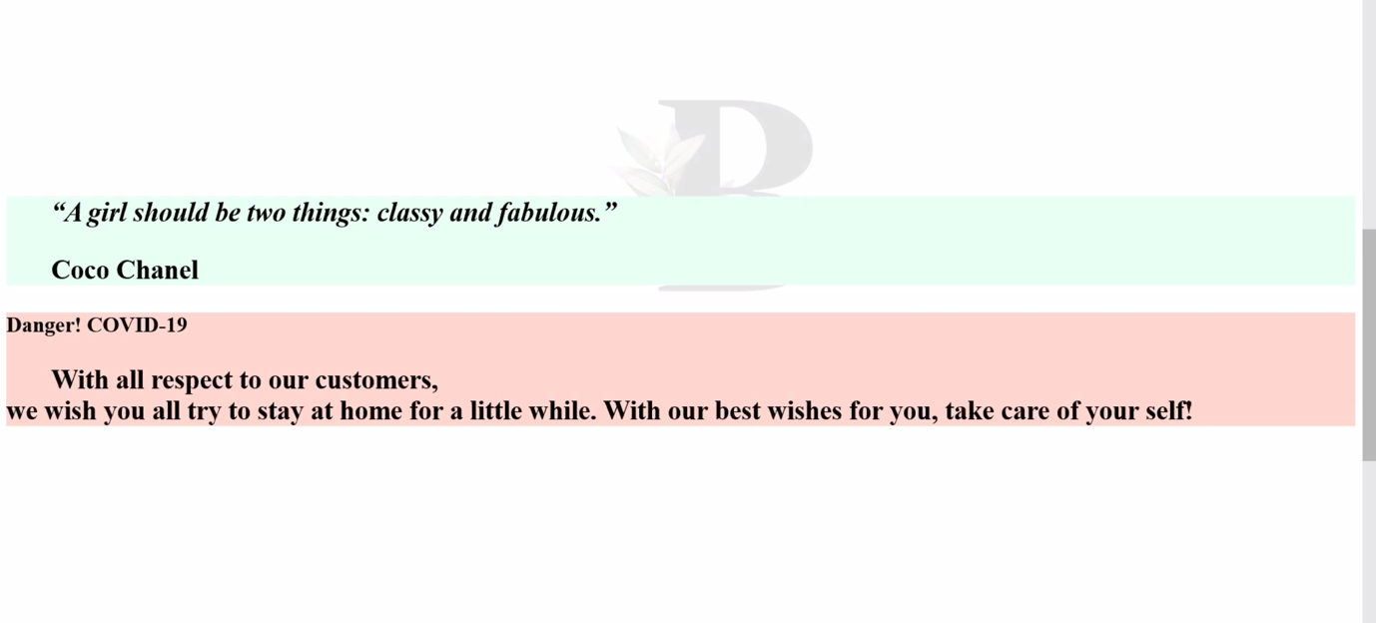

Figure 2 Messages

In figure 2, we write two messages for the user. The first is a famous quote for coco Chanel and the second for COVID-19.

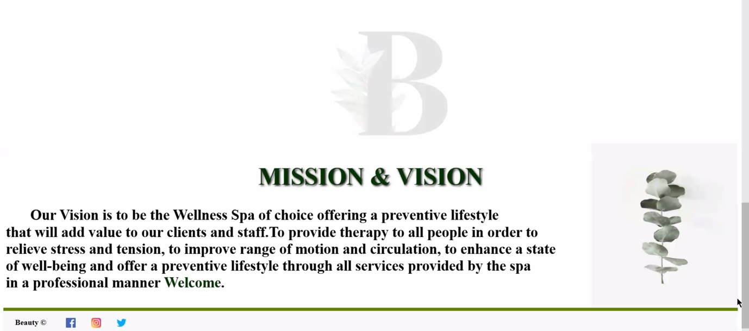

Figure 3 Mission and Vision

In figure 3, it is describing the mission and vision of the website.

## View item (Gallery) Page

In the gallery page the user can view the items information such as item name, price and item state if it is available, booked.

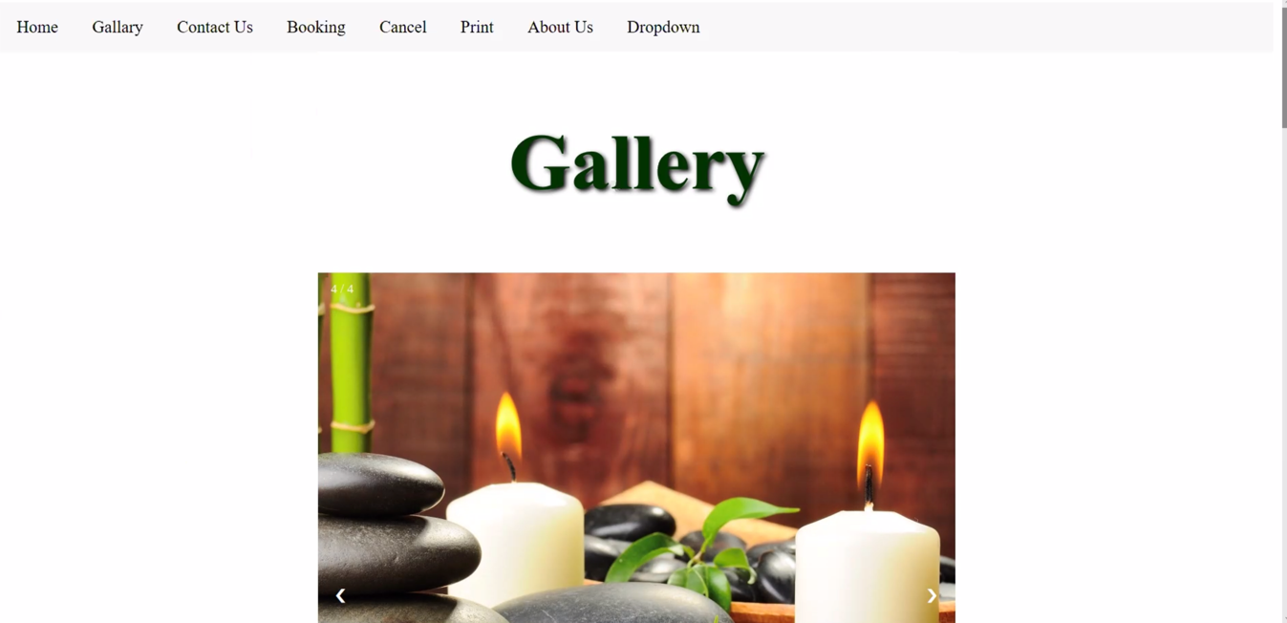

Figure 4 Gallery Page

In figure 4, it is displaying the gallery page.

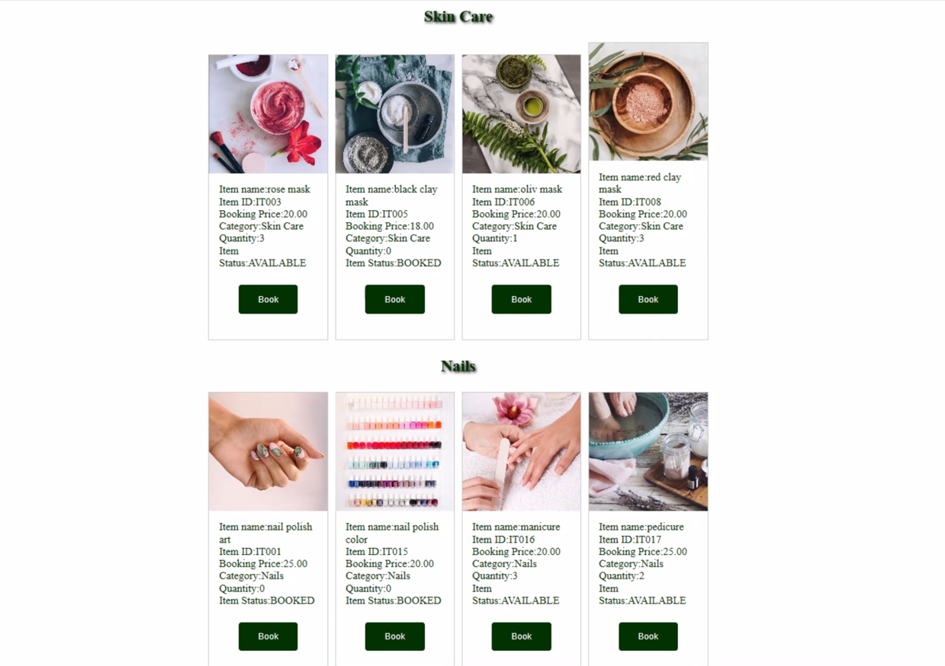

Figure 5 skin and nail item

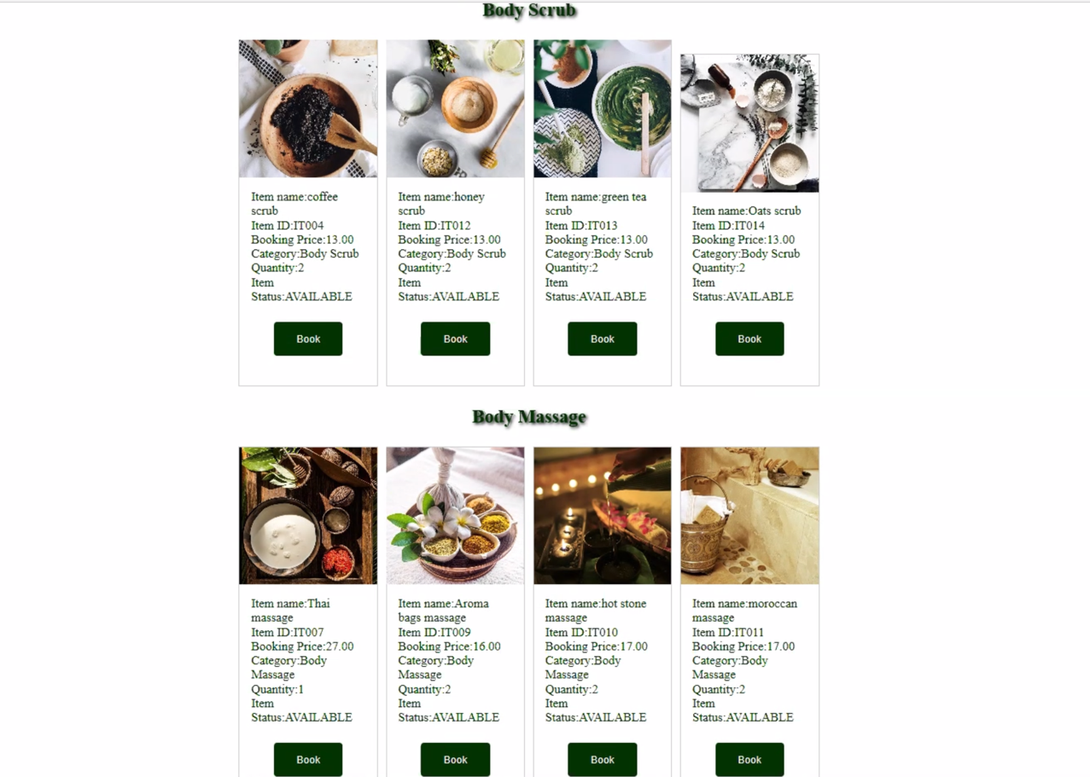

Figure 6 Body scrub and body massage item

In figure 5 and 6, we display the items for the user include Item Name, Item ID, Booking Price, Category, Quantity and Item status.

## Booking Page

In our System the most important page is the Booking page. Where the user can book an appointment depends on some criteria the user should enter their information passed on some formats such as , their FullName it has to be a character ,Phone Number must start with 00966 or 966 then choose the service which is skin care, nails, body scrub or body massage then choose the Item Id and it must start with [IT ---].Then the user must enter the quantity and their Location and District, after that choose the Date and Time, and all the information will be store in the Database.

Finally, the system will give the user a unique booking ID. That can be used to cancel or print an appointment summery.

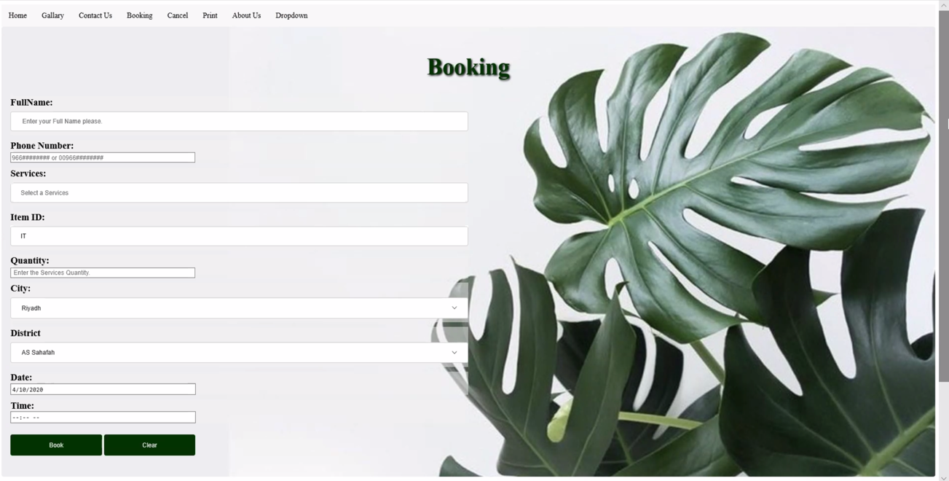

Figure 7 Booking Page

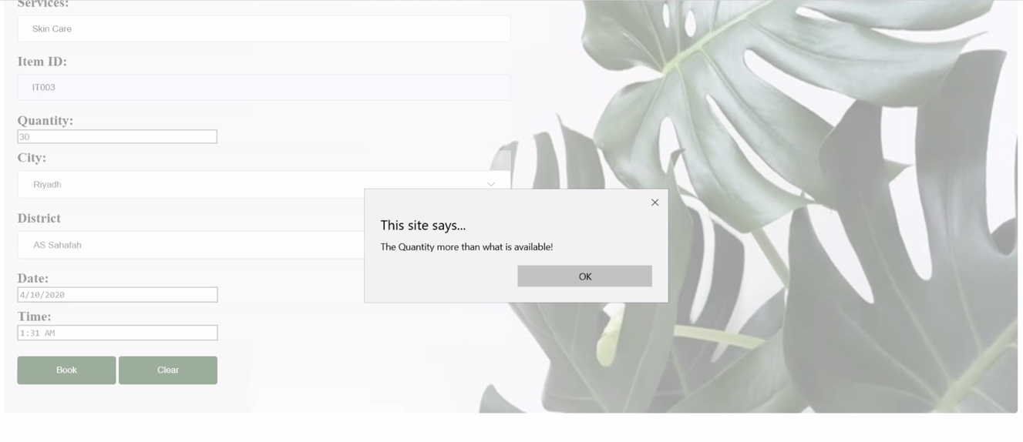

Figure 8 Quantity Alert

In figure 8, when the user enters a quantity more than what available in the database the system will alert the user before with message “The Quantity more than what is available”.

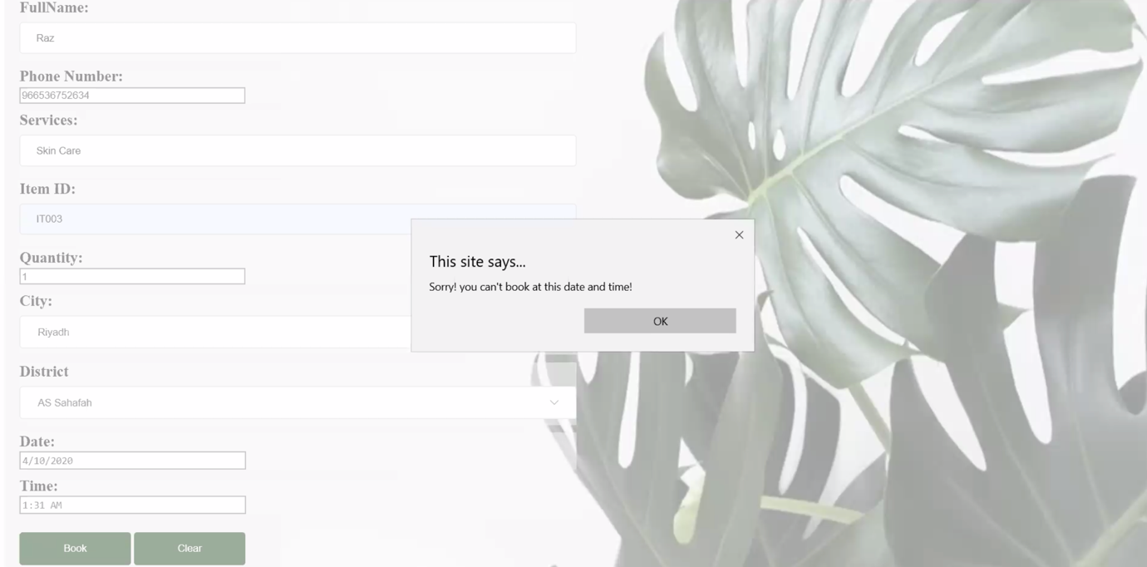

Figure 9 Time Alert

In figure 9, the system alerts the user if they try to book an appointment in unavailable time the system will alert with message “sorry! You can’t book at this date and time”.

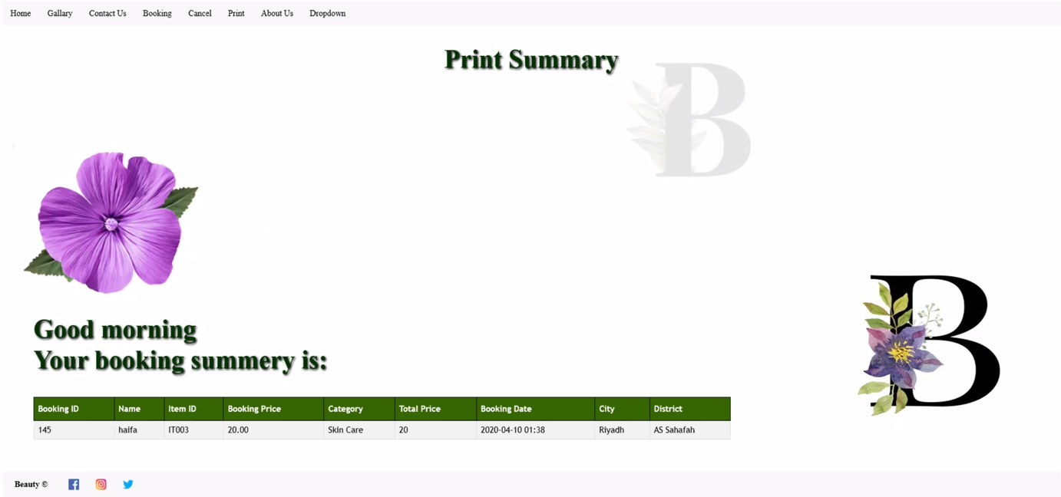

Figure 10 Booking Summery

In figure 10, the Booking summery includes Booking ID, Username, Item ID, Booking Price, Category, Total Price, Booking Date, City and District. The Total price includes the fees.

## Cancel Page

The user can use the Booking Id, to cancel their appointment. If the user cancels the appointment the total price will be return to the user after excluding the fees.

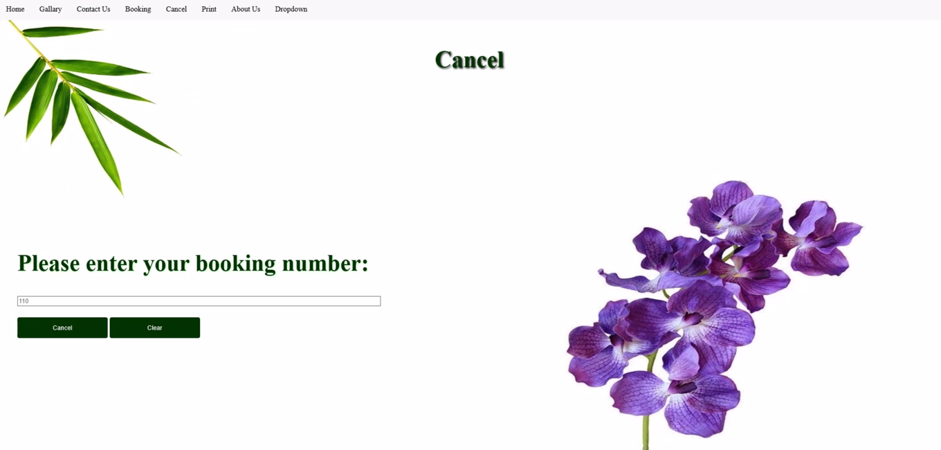

Figure 11 Cancel Page

In figure 11, the user will enter the appointment ID, then clicks cancel. Note: We chose a lavender background to make the user more relaxed.

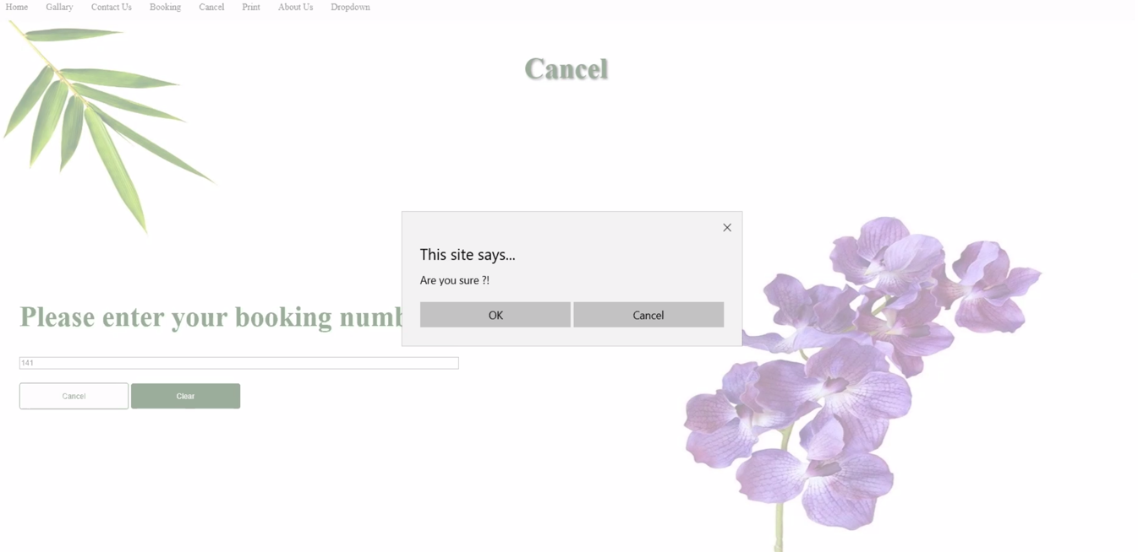

Figure 12 Cancel Alert

In figure 12, the system alerts the user if s/he is sure about canceling the appointment.

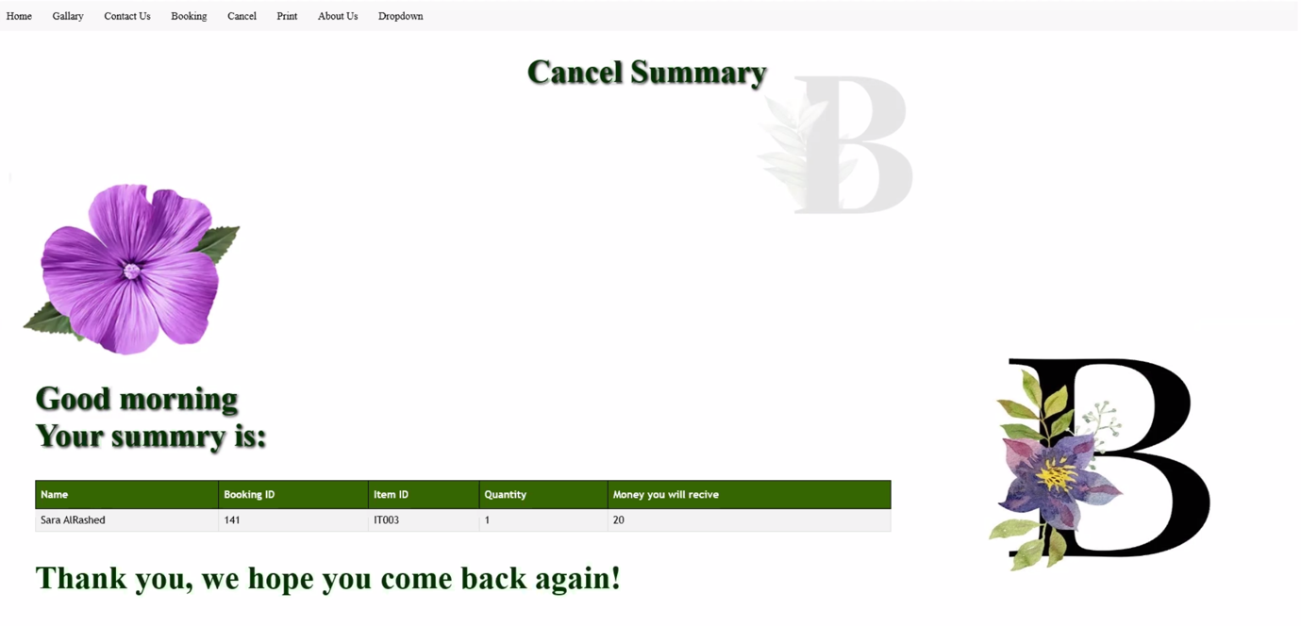

Figure 13 Cancel Print

In figure 13, the summery will be print to the user including Username, Booking ID, Item ID, Quantity and the returned money without the fees.

## Contact Us Page

We design contact us page to allow the user to be in touch with us. Using their FullName, E-mail and the comments all the information will be saved in the Database. Also, the user can view some pictures of our salon.

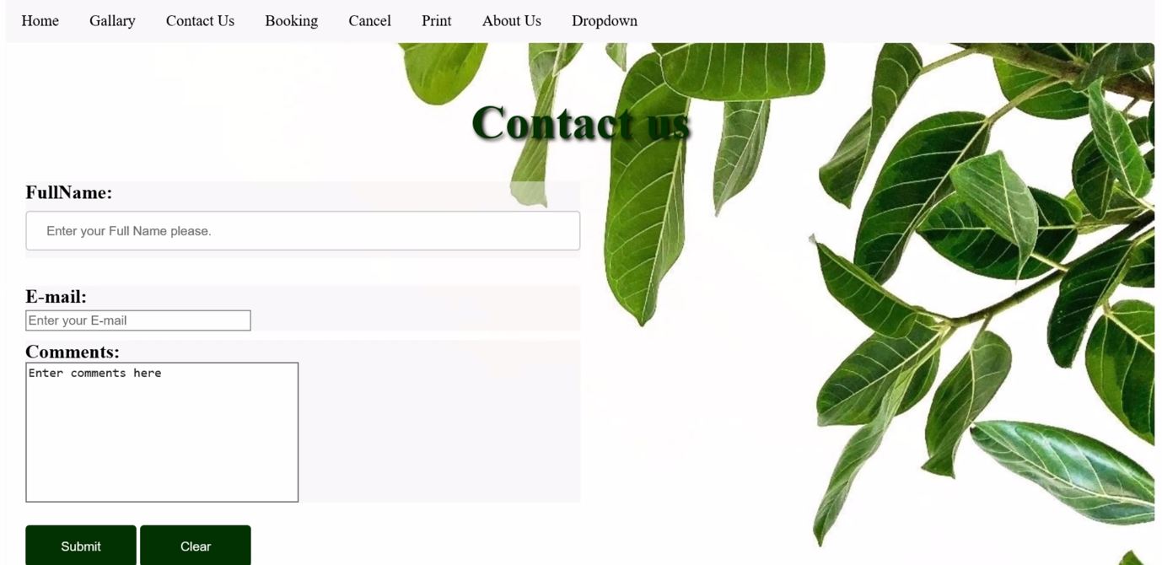

Figure 14 Contact Us Page

In figure 14, the users can enter their comments and send it to us.

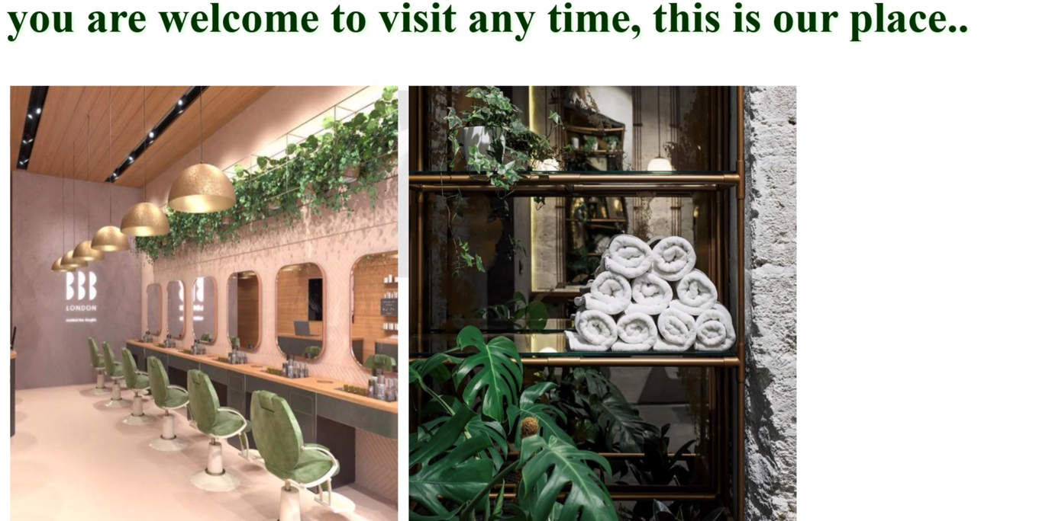

Figure 15 Place Picture1

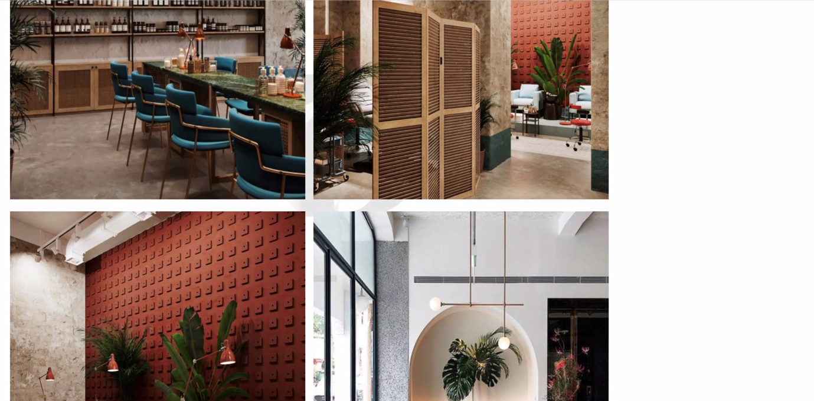

Figure 16 Place Picture 2

In figure 15and 16, we present some pictures of our salon.

## Print Page

The user can enter the booking ID then the system displays the booking information.

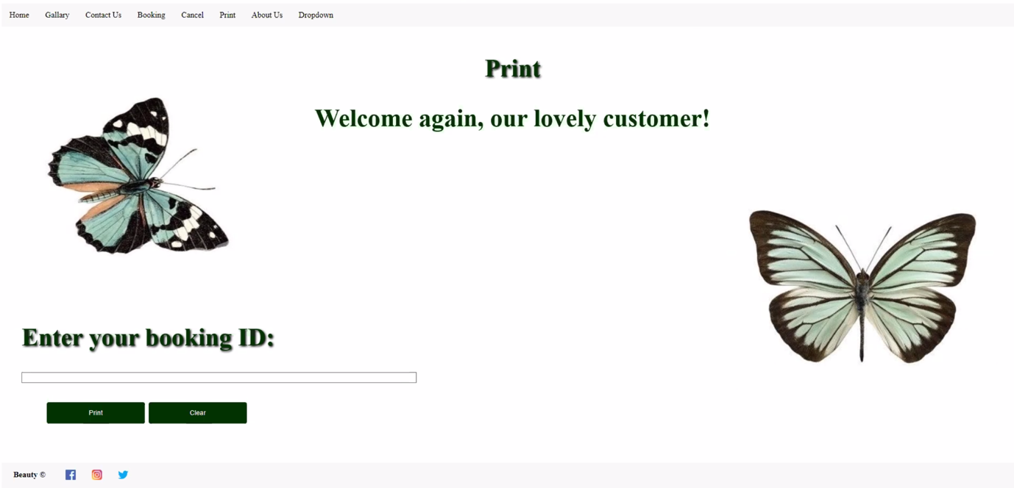

Figure 17 Print Page

In figure 17, the user has to enter the Booking ID to view their booking information.

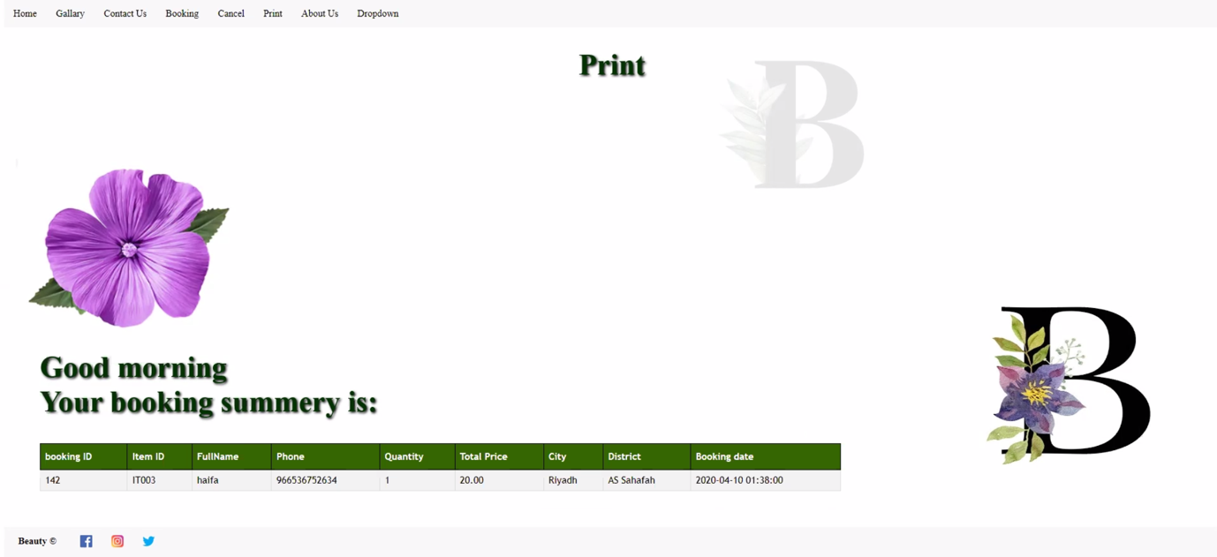

Figure 18 Print page output

In figure 18, the system displays the booking information.

# Data Base Tables:

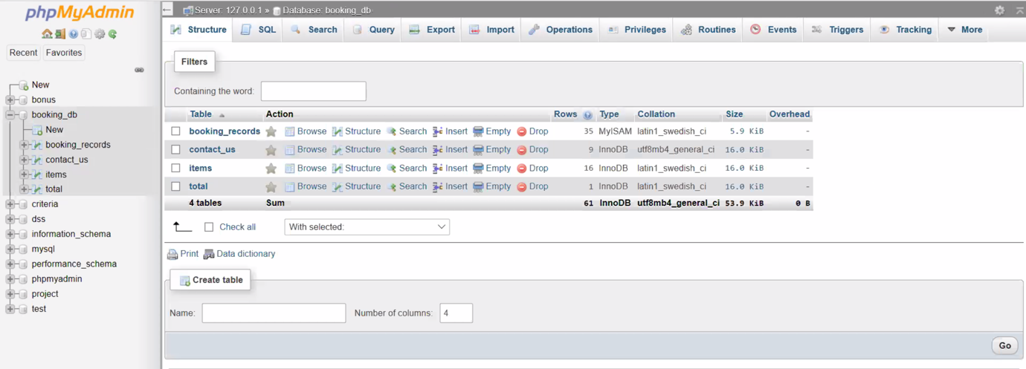

Figure 19 Booking DataBase

In figure 19, we present out the Database tables booking_records, contact_us, items and total.

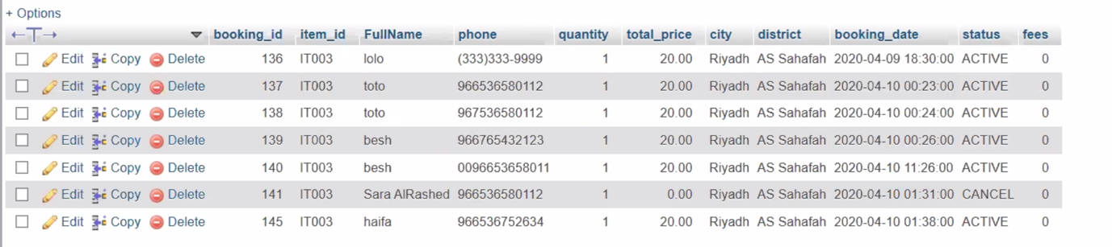

Figure 20 Booking_records database

In figure 20, we present out the saved information of the user when they booked an appointment. As you see there is no fees here because it less then 100.

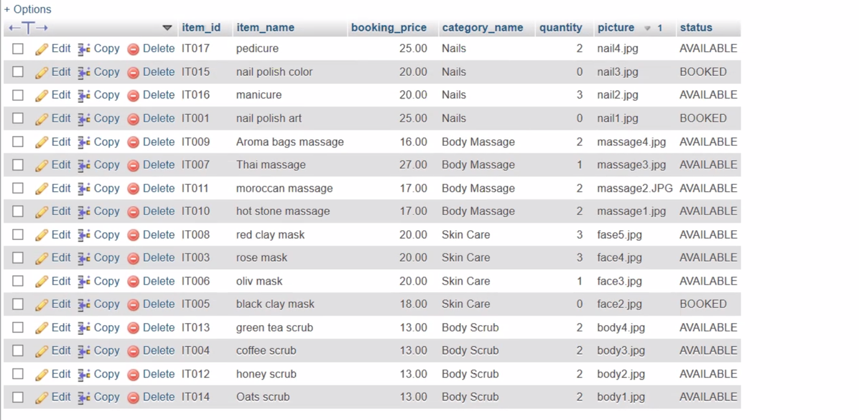

Figure 21 items database

In figure 21, here is the services we provide for the user.

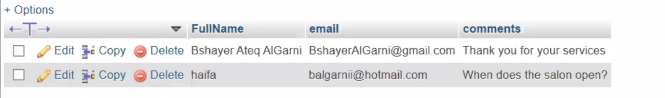

Figure 22 contact_us database

In figure 22, we store all the comment from our lovely users.

# Conclusions:

Our system helps customers to easily booking their appointment by using an online system, we think that the appointments will be much more than booking an appointment with the traditional way. When we talk about our conclusion as developers, we found that the HTML language is the most important one that creates the website, so the history of our website begins when we write HTML code. Then, we have to make the website user friendly and more comfortable to the user so, we must do styling with CSS. After that, to improve the functionality of our website we either used JavaScript or PHP. We also need a database to store the customers data and perform operations on them. It’s an important thing to connect the database with our website.